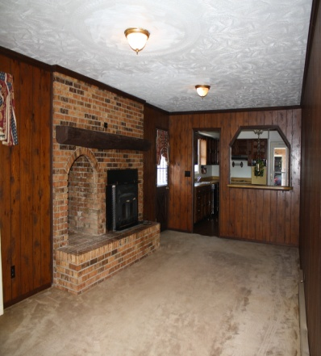
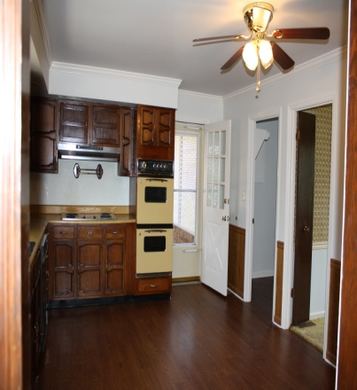
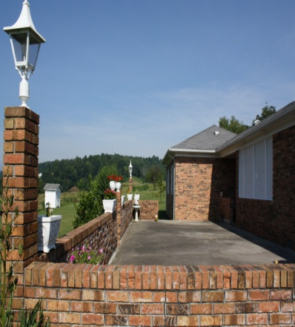
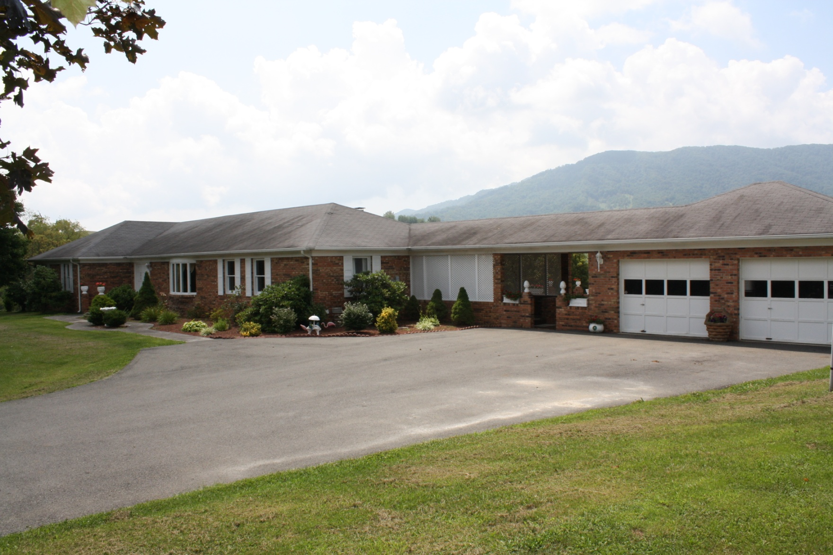
For
SALE
Ranch Home with Lots of Extras!
$219,000
Please call to arrange a private viewing Bee Stuart, Broker/Owner 540-529-6389 www.lebanonvarealestate.com

1438 Elk Garden Drive Elk Garden, VA
Single Family Property
Year Built: 1977
4 Total Bedroom(s)
2 Total Bath(s)
Approx. 2112 sq. ft.
Approx. 3.5 acre(s)
Large Yard
Brick Fireplace
Garden Area
2 Car Garage
Spacious Patio
Gorgeous View
Huge Den
Landscaped Yard

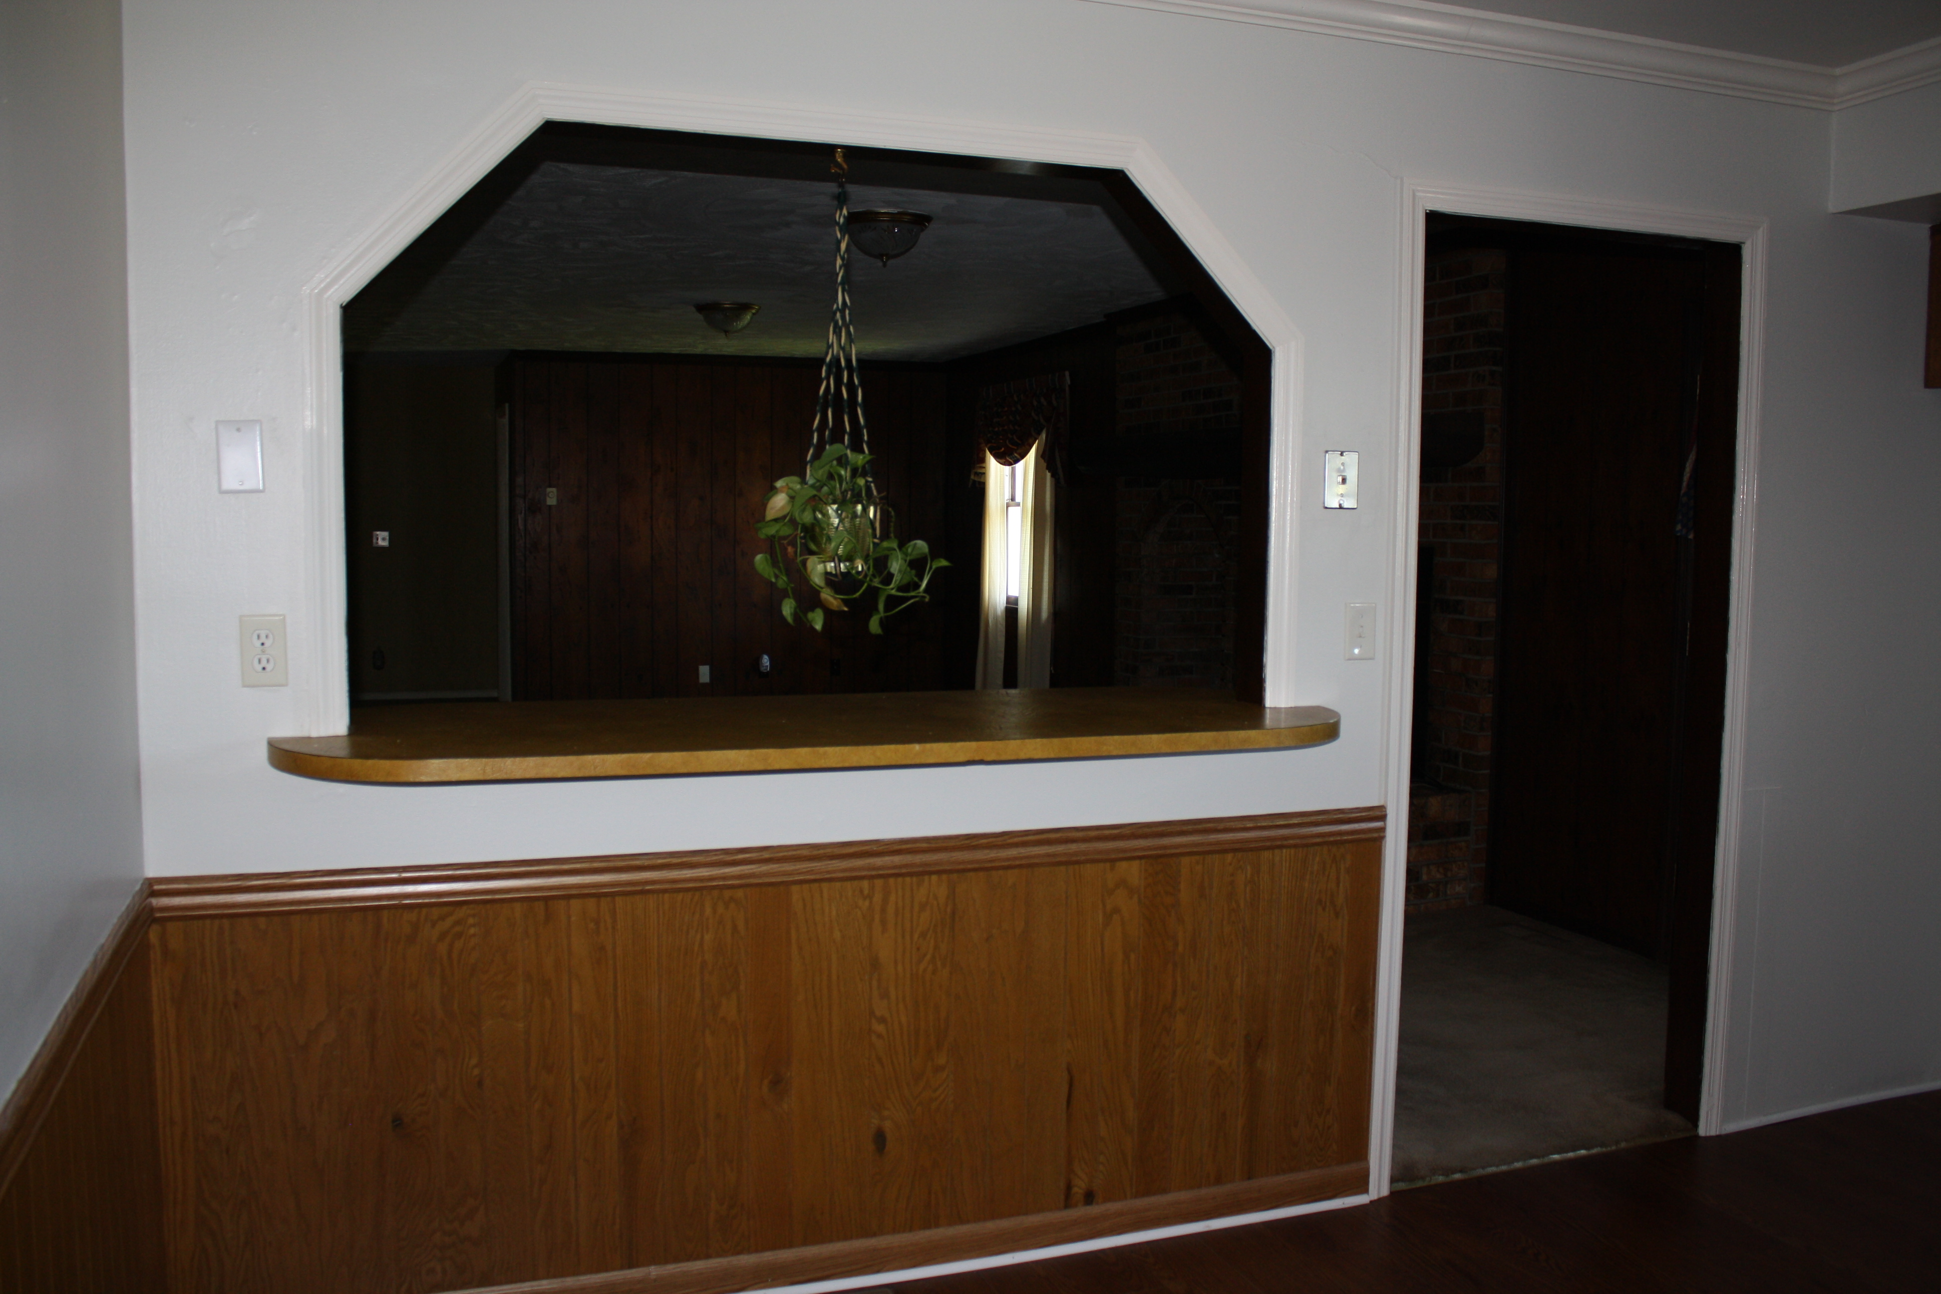

Stuart & Associates, Realtors
307 West Main Street
Lebanon, VA 24266

