FOR SALE: 5-Acre Horse Property | Seguin, TX
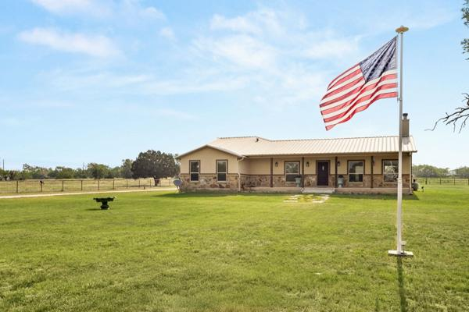

Property Highlights:
- 3-stall horse barn with climate-controlled tack/feed room
- Private guest apartment with full kitchen and bath
- In-ground pool with outdoor kitchen and covered patio
- Vaulted ceilings and stained concrete floors
- Chef’s kitchen with granite counters and gas cooking
- Split-bedroom layout for privacy and functionality
- Option to purchase adjoining 5 acres separately
Horse-ready, guest-ready, and built to entertain—this one’s turnkey, rare, and ready to roll.

Contact Jessi Riedel | Tarpon Blue Real Estate

